Product Name

Windmill Fastrack - Rinse Free Polish Stripper - 5L

Supplier

AUK Hygiene | www.aukhygiene.com | 01626 355177

Location

Completed By

Signature of Assessor

Date of Assessment

Date of Next Assessment

MSDS Revision Date

04/08/2025

Issue: 11.41

ALWAYS READ THE LABEL AND FOLLOW INSTRUCTIONS

Mop and leave for 5-10 minutes. Scrub floor with a slow speed rotary machine or scrubber dryer with black pad. Remove slurry with wet vacuum or scrubber dryer, reapply as necessary. Rinse thoroughly with water to neutralise before reapplying polish.

COSHH RISK ASSESSMENT

CLP Classification

Hazard Statements

H314 - Causes severe skin burns and eye damage. H335 - May cause respiratory irritation.

Intended Use

Polished Hard Floors

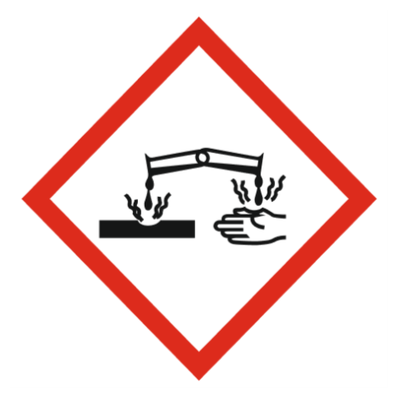
Corrosive

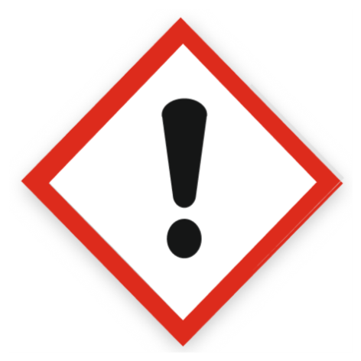
Health Hazard

Precautions Necessary

Further Action (If Applicable)

Actioned & Satisfactory

Spillage

Methods for cleaning up: Take up liquid spill into absorbent material.
Other information: Dispose of materials or solid residues at an authorized site.

☐ Yes

☐ No

Usage

Precautions for safe handling : Use only outdoors or in a well-ventilated area. Avoid contact with skin and eyes. Do not breathe vapours, spray. Wear personal protective equipment. Hygiene measures : Do not eat, drink or smoke when using this product

☐ Yes

☐ No

Storage

Store locked up. Store in a well-ventilated place. Keep container tightly closed. Keep cool.

☐ Yes

☐ No

Waste Treatment

Regional waste regulation: Dispose of in accordance with relevant local regulations.
Waste treatment methods: Dispose of contents/container in accordance with licensed collector’s sorting instructions.
Product/Packaging disposal recommendations: Dispose in a safe manner in accordance with local/national regulations.
European List of Waste (LoW, EC 2000/532): 20 01 29* - detergents containing dangerous substances

☐ Yes

☐ No

First Aid Measures

General First Aid Measures

Call a physician immediately.

After Skin Contact

Rinse skin with water/shower. Take off immediately all contaminated clothing. Call a physician immediately.

After Inhalation

Remove person to fresh air and keep comfortable for breathing.

After Eye Contact

Rinse cautiously with water for several minutes. Remove contact lenses, if present and easy to do. Continue rinsing. Call a physician immediately.

After Ingestion

Rinse mouth. Do not induce vomiting. Call a physician immediately.

Personal Protective Equipment

Eye and Face Protection Requirements

Safety glasses. Wear eye protection. ISO 16321-1

Skin Protection

Skin and body protection: Wear suitable protective clothing. Wear protective clothing
Hand protection: Wear protective gloves. Chemical resistant gloves (according to European standard ISO 374-1 or equivalent). Nitrile rubber gloves
Other skin protection
Materials for protective clothing: Safety boots. PICM008

Respiratory Protection

Not required for normal conditions of use

Measures for Monitoring (Including Health Surveillance where applicable)

Additional Considerations

Always maintain a good standard of occupational hygiene when handling chemicals. Avoid excessive skin contact. Use water proof gloves when necessary. When handling, do not eat, drink or smoke.





Fire Extinguishing Agent

Water

Foam

CO2

Dry Powder

