Product Name

Windmill Challenger - High Active Polish Stripper - 5L

Supplier

AUK Hygiene | www.aukhygiene.com | 01626 355177

Location

Completed By

Signature of Assessor

Date of Assessment

Date of Next Assessment

MSDS Revision Date

12/11/2025

Issue: 10.56

ALWAYS READ THE LABEL AND FOLLOW INSTRUCTIONS

Mop and leave for 5-10 minutes. Scrub floor with a slow speed rotary machine or scrubber dryer with black pad. Remove slurry with wet vacuum or scrubber dryer, reapply as necessary. Rinse thoroughly with water to neutralise before reapplying polish.

COSHH RISK ASSESSMENT

CLP Classification

Hazard Statements

H314 - Causes severe skin burns and eye damage.

Intended Use

Polished Hard Floors

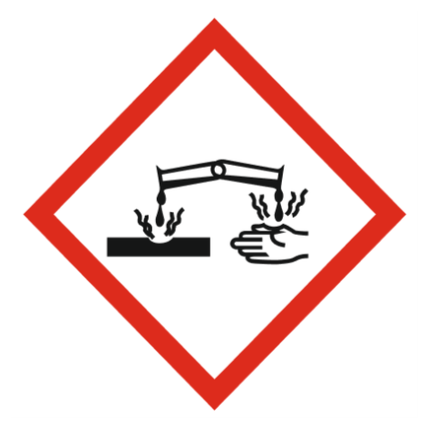
Corrosive

Precautions Necessary

Further Action (If Applicable)

Actioned & Satisfactory

First Aid Measures

General First Aid Measures

Get medical advice/attention if you feel unwell.

After Skin Contact

Wash skin with plenty of water. Take off immediately all contaminated clothing and wash it before reuse. Get medical advice/attention.

After Inhalation

Remove person to fresh air and keep comfortable for breathing.

After Eye Contact

Rinse cautiously with water for several minutes. Remove contact lenses, if present and easy to do. Continue rinsing. If eye irritation persists: Get medical advice/attention.

After Ingestion

Do NOT induce vomiting. Rinse mouth. Drink plenty of water. Get medical advice/attention.

Personal Protective Equipment

Eye and Face Protection Requirements

Safety glasses. Wear eye protection. ISO 16321-1

Skin Protection

Skin and body protection: Wear suitable protective clothing. Wear protective clothing
Hand protection: Wear protective gloves. Chemical resistant gloves (according to European standard ISO 374-1 or equivalent). Nitrile rubber gloves
Other skin protection
Materials for protective clothing: Safety boots. PICM008

Respiratory Protection

Not required for normal conditions of use

Measures for Monitoring (Including Health Surveillance where applicable)

Additional Considerations

Always maintain a good standard of occupational hygiene when handling chemicals. Avoid excessive skin contact. Use water proof gloves when necessary. When handling, do not eat, drink or smoke.





Fire Extinguishing Agent

Water

Foam

CO2

Dry Powder

Spillage

For containment: Collect spillage.
Methods for cleaning up: Soak up spills with inert solids, such as clay or diatomaceous earth as soon as possible.

☐ Yes

☐ No

Usage

Precautions for safe handling: Avoid contact with eyes. Hygiene measures: Do not eat, drink or smoke when using this product.

☐ Yes

☐ No

Storage

Keep container closed when not in use.

☐ Yes

☐ No

Waste Treatment

No additional information available

☐ Yes

☐ No

