Product Name

Windmill SD Light - Low Foam Neutral Cleaner - 5L

Supplier

AUK Hygiene | www.aukhygiene.com | 01626 355177

Location

Completed By

Signature of Assessor

Date of Assessment

Date of Next Assessment

MSDS Revision Date

30/10/2025

Issue: 10.51

ALWAYS READ THE LABEL AND FOLLOW INSTRUCTIONS

Dilute into mop bucket or tank of scrubber drier for floor cleaning.

COSHH RISK ASSESSMENT

CLP Classification

Hazard Statements

H319 - Causes serious eye irritation.

Intended Use

Polished Hard Floors (Suitable for Scrubber Driers)

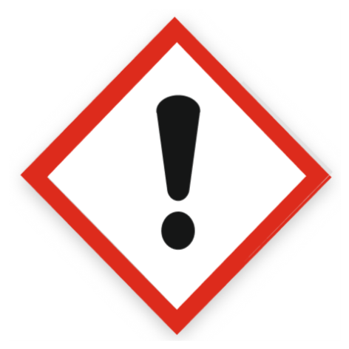
Health Hazard

Precautions Necessary

Further Action (If Applicable)

Actioned & Satisfactory

First Aid Measures

General First Aid Measures

After Skin Contact

Wash skin with plenty of water.

After Inhalation

Remove person to fresh air and keep comfortable for breathing.

After Eye Contact

IF IN EYES: Rinse cautiously with water for several minutes. Remove contact lenses, if present and easy to do. Continue rinsing. If eye irritation persists: Get medical advice/attention.

After Ingestion

Give nothing or a little water to drink. Get medical advice/attention if you feel unwell.

Personal Protective Equipment

Eye and Face Protection Requirements

Wear eye protection. Safety glasses. ISO 16321-1

Skin Protection

Skin and body protection: Not required for normal conditions of use.
Hand protection: In case of repeated or prolonged contact wear gloves. Chemical resistant gloves (according to European standard ISO 374-1 or equivalent)

Respiratory Protection

Not required for normal conditions of use

Measures for Monitoring (Including Health Surveillance where applicable)

No additional information available

Additional Considerations

Always maintain a good standard of occupational hygiene when handling chemicals. Avoid excessive skin contact. Use water proof gloves when necessary. When handling, do not eat, drink or smoke.



Fire Extinguishing Agent

Water

Foam

CO2

Dry Powder

Spillage

For containment: Collect spillage.
Methods for cleaning up: Soak up spills with inert solids, such as clay or diatomaceous earth as soon as possible.

☐ Yes

☐ No

Usage

Precautions for safe handling: Avoid contact with eyes. Hygiene measures: Do not eat, drink or smoke when using this product.

☐ Yes

☐ No

Storage

Keep container closed when not in use.

☐ Yes

☐ No

Waste Treatment

Regional waste regulation: Dispose of in accordance with relevant local regulations.
Waste treatment methods: Dispose of contents/container in accordance with licensed collector’s sorting instructions.
Product/Packaging disposal recommendations: Dispose in a safe manner in accordance with local/national regulations.
European List of Waste (LoW, EC 2000/532): 20 01 29* - detergents containing dangerous substances

☐ Yes

☐ No

