Product Name

Evans Q'sol Superior Washing Up Liquid – 2 x 5L

Supplier

AUK Hygiene | www.aukhygiene.com | 01626 355177

Location

Completed By

Signature of Assessor

Date of Assessment

Date of Next Assessment

MSDS Revision Date

09/03/2026

Issue: 10

ALWAYS READ THE LABEL AND FOLLOW INSTRUCTIONS

Dilute as directed, remove food residue before washing crockery and utensils then rinse and air dry, or apply the solution to surfaces by mopping or wiping for general cleaning.

COSHH RISK ASSESSMENT

CLP Classification

Hazard Statements

H315 Causes skin irritation. H319 Causes serious eye irritation. H412 Harmful to aquatic life with long lasting effects.

Intended Use

Washing up and geneal cleaning

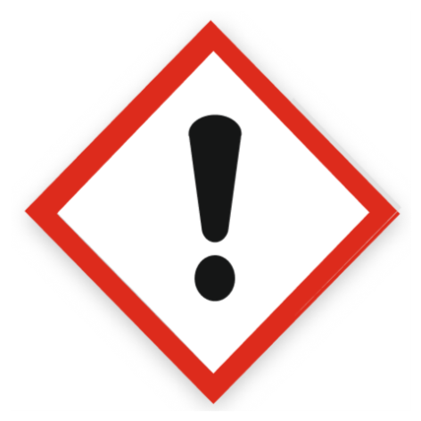
Health Hazard

Precautions Necessary

Further Action (If Applicable)

Actioned & Satisfactory

Spillage

Methods and material for cleaning up
Small Spillages: Flush away spillage with plenty of water to drain.
Large Spillages: Contain and absorb spillage with sand, earth or other non-combustible material. Collect and place in suitable waste disposal containers and seal securely.

☐ Yes

☐ No

Usage

Recommendation - For handling undiluted product: Wear protective clothing, gloves, eye and face protection. Advices on general occupational hygiene - Avoid contact with skin, eyes and clothes.

☐ Yes

☐ No

Storage

Keep/store only in original container.
Keep container tightly closed in a cool, well-ventilated place.
Store away from the following materials: Oxidising materials

☐ Yes

☐ No

First Aid Measures

General First Aid Measures

After Skin Contact

Wash immediately with water.

After Inhalation

Unlikely route of exposure as the product does not contain volatile substances. If spray/mist has been inhaled, proceed as follows. Move affected person to fresh air and keep warm and at rest in a position comfortable for breathing.

After Eye Contact

Rinse immediately with plenty of water. Remove any contact lenses, if present and easy to do, continue to rinse with eyelids apart. Get medical attention immediately.

After Ingestion

Do NOT induce vomiting. Give plenty of water to drink. Get medical attention if any discomfort continues.

Personal Protective Equipment

Eye and Face Protection Requirements

Eye protection

Skin Protection

Protective gloves. Wear appropriate clothing to prevent any possibility of skin
contact.

Respiratory Protection

Respiratory protection not required.

Measures for Monitoring (Including Health Surveillance where applicable)

Additional Considerations

Always maintain a good standard of occupational hygiene when handling chemicals. Avoid excessive skin contact. Use water proof gloves when necessary. When handling, do not eat, drink or smoke.



Fire Extinguishing Agent

Water

Foam

CO2

Dry Powder

Waste Treatment

Discharge used solutions to drain. Small amounts (less than 5 Litres) of unwanted product may be flushed with water to sewer. Larger volumes must be sent for disposal by approved waste contractor. Rinse out empty container with water and consign to normal waste.

☐ Yes

☐ No

