Product Name

Windmill Kettle and Shower Head Descaler - 500ml

Supplier

AUK Hygiene | www.aukhygiene.com | 01626 355177

Location

Completed By

Signature of Assessor

Date of Assessment

Date of Next Assessment

MSDS Revision Date

17/07/2025

Issue: 10.53

ALWAYS READ THE LABEL AND FOLLOW INSTRUCTIONS

Add 125 ml of descaler to warm water, soak kettles without heating for at least 4 hours (then rinse, boil clean water, and rinse again) and soak shower heads until limescale is removed before rinsing thoroughly.

COSHH RISK ASSESSMENT

CLP Classification

Hazard Statements

H314 - Causes severe skin burns and eye damage.

Intended Use

Kettles and Shower Heads

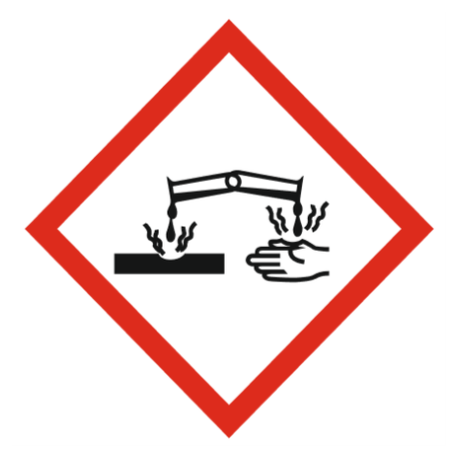
Corrosive

Precautions Necessary

Further Action (If Applicable)

Actioned & Satisfactory

First Aid Measures

General First Aid Measures

Get medical advice/attention if you feel unwell.

After Skin Contact

Wash with plenty of water/…. Take off immediately all contaminated clothing and wash it before reuse.

After Inhalation

Remove person to fresh air and keep comfortable for breathing.

After Eye Contact

Immediately rinse with water for a prolonged period while holding the eyelids wide open. Get immediate medical advice/attention.

After Ingestion

Immediately rinse with water for a prolonged period while holding the eyelids wide open. Get immediate medical advice/attention.

Personal Protective Equipment

Eye and Face Protection Requirements

Wear eye protection. Safety glasses. ISO 16321-1

Skin Protection

Skin and body protection: Not required for normal conditions of use
Hand protection:Chemical resistant gloves (according to European standard ISO 374-1 or equivalent). Nitrile rubber gloves. Wear protective gloves

Respiratory Protection

Not required for normal conditions of use

Measures for Monitoring (Including Health Surveillance where applicable)

Additional Considerations

Always maintain a good standard of occupational hygiene when handling chemicals. Avoid excessive skin contact. Use water proof gloves when necessary. When handling, do not eat, drink or smoke.



Fire Extinguishing Agent

Water

Foam

CO2

Dry Powder

Spillage

For containment: Collect spillage.
Methods for cleaning up: Soak up spills with inert solids, such as clay or diatomaceous earth as soon as possible.

☐ Yes

☐ No

Usage

Precautions for safe handling: Avoid contact with eyes. Hygiene measures: Do not eat, drink or smoke when using this product.

☐ Yes

☐ No

Storage

Keep container closed when not in use.

☐ Yes

☐ No

Waste Treatment

Regional waste regulation: Dispose of in accordance with relevant local regulations.
Waste treatment methods: Dispose of contents/container in accordance with licensed collector’s sorting instructions.
Product/Packaging disposal recommendations: Dispose in a safe manner in accordance with local/national regulations.
European List of Waste (LoW, EC 2000/532): 20 01 29* - detergents containing dangerous substances

☐ Yes

☐ No

