Product Name

Evans Hi-Phos Heavy Duty Cleaner Descaler RTU - 1L

Supplier

AUK Hygiene | www.aukhygiene.com | 01626 355177

Location

Completed By

Signature of Assessor

Date of Assessment

Date of Next Assessment

MSDS Revision Date

10/03/2026

Issue: 14

ALWAYS READ THE LABEL AND FOLLOW INSTRUCTIONS

Toilets and Urinals: Flush toilet or urinals. Force water around S bend with toilet brush. Apply undiluted and leave for a few minutes. Agitate with brush if necessary. Flush with clean water.

COSHH RISK ASSESSMENT

CLP Classification

Hazard Statements

H314 Causes severe skin burns and eye damage.

Intended Use

Toilet And Urinals

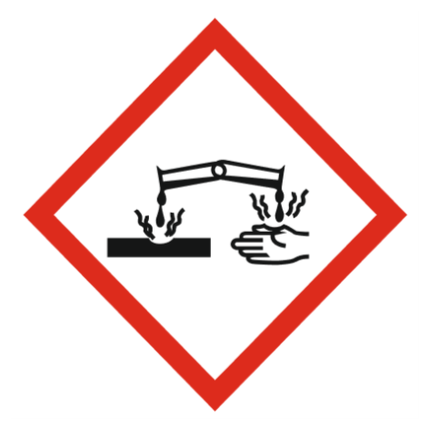
Corrosive

Precautions Necessary

Further Action (If Applicable)

Actioned & Satisfactory

First Aid Measures

Spillage

Methods and material for cleaning up
Small Spillages: Flush away spillage with plenty of water to drain.
Large Spillages: Contain and absorb spillage with sand, earth or other non-combustible material. Collect and place in suitable waste disposal containers and seal securely.

☐ Yes

☐ No

Usage

Wear personal protective clothing.

☐ Yes

☐ No

Storage

Keep/store only in original container.
Keep container tightly closed in a cool, well-ventilated place.
Store away from the following materials: Oxidising materials, (eg Hypochlorite/Bleach) Alkalis

☐ Yes

☐ No

Waste Treatment

Discharge used solutions to drain. Small amounts (less than 5 Litres) of unwanted product may be flushed with water to sewer. Larger volumes must be sent for disposal by approved waste contractor. Rinse out empty container with water and consign to normal waste.

☐ Yes

☐ No

General First Aid Measures

After Skin Contact

Wash immediately with water. Get medical attention promptly if symptoms occur after washing.

After Inhalation

Unlikely route of exposure as the product does not contain volatile substances. If spray/mist has been inhaled, proceed as follows. Move affected person to fresh air and keep warm and at rest in a position comfortable for breathing.

After Eye Contact

Rinse immediately with plenty of water. Remove any contact lenses, if present and easy to do, continue to rinse with eyelids apart. Get medical attention immediately.

After Ingestion

Do NOT induce vomiting. Rinse mouth thoroughly with water. Give plenty of water to drink. Get medical attention immediately.

Personal Protective Equipment

Eye and Face Protection Requirements

Eye protection

Skin Protection

Wear protective gloves. Wear appropriate clothing to prevent any possibility of skin contact.

Respiratory Protection

Respiratory protection not required.

Measures for Monitoring (Including Health Surveillance where applicable)

Additional Considerations

Always maintain a good standard of occupational hygiene when handling chemicals. Avoid excessive skin contact. Use water proof gloves when necessary. When handling, do not eat, drink or smoke.



Fire Extinguishing Agent

Water

Foam

CO2

Dry Powder

