Product Name

Evans Clean Fast Washroom Cleaner Descaler - 2X5L

Supplier

AUK Hygiene | www.aukhygiene.com | 01626 355177

Location

Completed By

Signature of Assessor

Date of Assessment

Date of Next Assessment

MSDS Revision Date

09/03/2026

Issue: 15

ALWAYS READ THE LABEL AND FOLLOW INSTRUCTIONS

Spray onto the surface and wipe with a clean damp cloth. For stubborn soiling and limescale, spray onto surface and leave for 30 seconds before agitating and wiping off.

COSHH RISK ASSESSMENT

CLP Classification

Hazard Statements

H319 Causes serious eye irritation. H412 Harmful to aquatic life with long lasting effects.

Intended Use

Washrooms

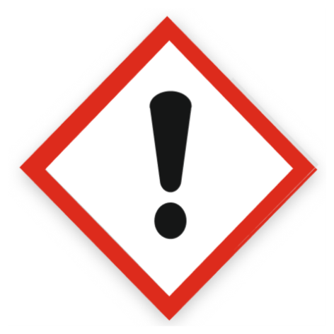
Health Hazard

Precautions Necessary

Further Action (If Applicable)

Actioned & Satisfactory

Spillage

Methods and material for cleaning up
Small Spillages: Flush away spillage with plenty of water to drain.
Large Spillages: Contain and absorb spillage with sand, earth or other non-combustible material. Collect and place in suitable waste disposal containers and seal securely.

☐ Yes

☐ No

Usage

Recommendation - For handling undiluted product: Wear protective clothing, gloves, eye and face protection. Advices on general occupational hygiene - Avoid contact with skin, eyes and clothes.

☐ Yes

☐ No

Storage

Keep/store only in original container.
Keep container tightly closed in a cool, well-ventilated place.
Store away from the following materials: Oxidising materials

☐ Yes

☐ No

First Aid Measures

General First Aid Measures

After Skin Contact

Wash with plenty of water.

After Inhalation

Unlikely route of exposure as the product does not contain volatile substances. If spray/mist has been inhaled, proceed as follows. Move affected person to fresh air and keep warm and at rest in a position comfortable for breathing.

After Eye Contact

Rinse immediately with plenty of water. Remove any contact lenses, if present and easy to do, continue to rinse with eyelids apart. Get medical attention immediately.

After Ingestion

Do NOT induce vomiting. Give plenty of water to drink. Get medical attention if any discomfort continues.

Personal Protective Equipment

Eye and Face Protection Requirements

Eye Protection

Skin Protection

No specific hand protection required, but for prolonged or repeated skin contact use it is recommended to wear suitable gloves.

Respiratory Protection

Respiratory protection not required.

Measures for Monitoring (Including Health Surveillance where applicable)

Additional Considerations

Always maintain a good standard of occupational hygiene when handling chemicals. Avoid excessive skin contact. Use water proof gloves when necessary. When handling, do not eat, drink or smoke.


Fire Extinguishing Agent

Water

Foam

CO2

Dry Powder

Waste Treatment

Discharge used solutions to drain. Small amounts (less than 5 Litres) of unwanted product may be flushed with water to sewer. Larger volumes must be sent for disposal by approved waste contractor. Rinse out empty container with water and consign to normal waste.

☐ Yes

☐ No

