Product Name

Windmill Victory Foaming Washroom Cleaner - 5L

Supplier

AUK Hygiene | www.aukhygiene.com | 01626 355177

Location

Completed By

Signature of Assessor

Date of Assessment

Date of Next Assessment

MSDS Revision Date

07/10/2025

Issue: 10.61

ALWAYS READ THE LABEL AND FOLLOW INSTRUCTIONS

Simply spray onto cloth or sponge as required and wipe away grime. Leaving foam on surface for a few minutes before wiping off will assist in body fat removal and ensure effective sanitising.

COSHH RISK ASSESSMENT

CLP Classification

Hazard Statements

H319 - Causes serious eye irritation. H412 - Harmful to aquatic life with long lasting effects.

Intended Use

Surfaces

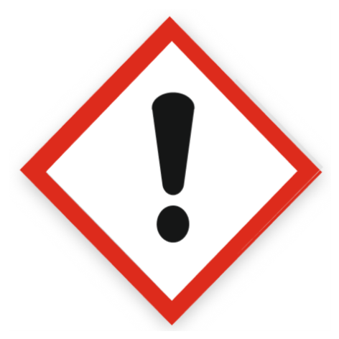
Health Hazard

Precautions Necessary

Further Action (If Applicable)

Actioned & Satisfactory

Spillage

Methods for cleaning up: Take up liquid spill into absorbent material.
Other information: Dispose of materials or solid residues at an authorized site.

☐ Yes

☐ No

Usage

Precautions for safe handling: Ensure good ventilation of the work station. Avoid contact with skin and eyes. Wear personal protective equipment. Hygiene measures: Do not eat, drink or smoke when using this product.

☐ Yes

☐ No

Storage

Store in a well-ventilated place. Keep cool.

☐ Yes

☐ No

Waste Treatment

Regional waste regulation: Dispose of in accordance with relevant local regulations.
Waste treatment methods: Dispose of contents/container in accordance with licensed collector’s sorting instructions.
Product/Packaging disposal recommendations: Dispose in a safe manner in accordance with local/national regulations.
European List of Waste (LoW, EC 2000/532): 20 01 29* - detergents containing dangerous substances

☐ Yes

☐ No

First Aid Measures

General First Aid Measures

After Skin Contact

Wash skin with plenty of water.

After Inhalation

Remove person to fresh air and keep comfortable for breathing.

After Eye Contact

Rinse cautiously with water for several minutes. Remove contact lenses, if present and easy to do. Continue rinsing. If eye irritation persists: Get medical advice/attention.

After Ingestion

Get immediate medical advice/attention.

Personal Protective Equipment

Eye and Face Protection Requirements

Safety glasses. Wear eye protection. ISO 16321-1

Skin Protection

Skin and body protection: Not required for normal conditions of use.
Hand protection: In case of repeated or prolonged contact wear gloves. Chemical resistant gloves (according to European standard ISO 374-1 or equivalent). Nitrile
rubber gloves

Respiratory Protection

Not required for normal conditions of use

Measures for Monitoring (Including Health Surveillance where applicable)

No additional information available

Additional Considerations

Always maintain a good standard of occupational hygiene when handling chemicals. Avoid excessive skin contact. Use water proof gloves when necessary. When handling, do not eat, drink or smoke.



Fire Extinguishing Agent

Water

Foam

CO2

Dry Powder

