Product Name

Evans Clear Glass Cleaner Refill – 5L

Supplier

AUK Hygiene | www.aukhygiene.com | 01626 355177

Location

Completed By

Signature of Assessor

Date of Assessment

Date of Next Assessment

MSDS Revision Date

10/03/2026

Issue: 13

ALWAYS READ THE LABEL AND FOLLOW INSTRUCTIONS

Spray sparingly directly onto surface and wipe clean immediately with a clean, dry cloth. For small areas, spray onto cloth then wipe surface.

COSHH RISK ASSESSMENT

CLP Classification

Hazard Statements

H226 Flammable liquid and vapour.

Intended Use

Windows, glass and stainless steel

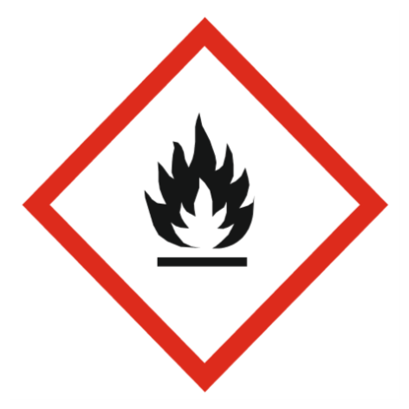
Flammable

Precautions Necessary

Further Action (If Applicable)

Actioned & Satisfactory

First Aid Measures

Spillage

Methods and material for cleaning up
Small Spillages: Flush away spillage with plenty of water to drain.
Large Spillages: Contain and absorb spillage with sand, earth or other non-combustible material. Collect and place in suitable waste disposal containers and seal securely.

☐ Yes

☐ No

Usage

Keep away from sources of ignition - No smoking.

☐ Yes

☐ No

Storage

Keep/store only in original container.
Keep container tightly closed in a cool, well-ventilated place.
Store away from the following materials: Oxidising materials

☐ Yes

☐ No

Waste Treatment

Discharge used solutions to drain. Small amounts (less than 5 Litres) of unwanted product may be flushed with water to sewer. Larger volumes must be sent for disposal by approved waste contractor. Rinse out empty container with water and consign to normal waste.

☐ Yes

☐ No

General First Aid Measures

After Skin Contact

Wash with plenty of water.

After Inhalation

Unlikely route of exposure as the product does not contain volatile substances. If spray/mist has been inhaled, proceed as follows. Move affected person to fresh air and keep warm and at rest in a position comfortable for breathing.

After Eye Contact

Rinse immediately with plenty of water. Get medical attention if irritation persists after washing.

After Ingestion

Do NOT induce vomiting. Give plenty of water to drink. Get medical attention if any discomfort continues.

Personal Protective Equipment

Eye and Face Protection Requirements

No specific eye protection required during normal use.

Skin Protection

No specific hand protection required, but for prolonged or repeated skin contact use it is recommended to wear suitable gloves.
No specific body protection required during normal use.

Respiratory Protection

Respiratory protection not required.

Measures for Monitoring (Including Health Surveillance where applicable)

Additional Considerations

Always maintain a good standard of occupational hygiene when handling chemicals. Avoid excessive skin contact. Use water proof gloves when necessary. When handling, do not eat, drink or smoke.

Fire Extinguishing Agent

Water

Foam

CO2

Dry Powder

