Product Name

Windmill Invincible Bactericidal Cleaner - 10L - Windmill Refill

Supplier

AUK Hygiene | www.aukhygiene.com | 01626 355177

Location

Completed By

Signature of Assessor

Date of Assessment

Date of Next Assessment

MSDS Revision Date

03/06/2025

Issue: 10.81

ALWAYS READ THE LABEL AND FOLLOW INSTRUCTIONS

For cleaning any hard surfaces in washroom or general areas. Spray on, allow contact time and wipe off.

COSHH RISK ASSESSMENT

CLP Classification

Hazard Statements

H315 - Causes skin irritation. H318 - Causes serious eye damage. H410 - Very toxic to aquatic life with long lasting effects.

Intended Use

Hard Surfaces and Touch Points

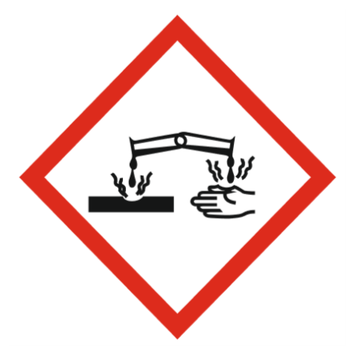
Corrosive

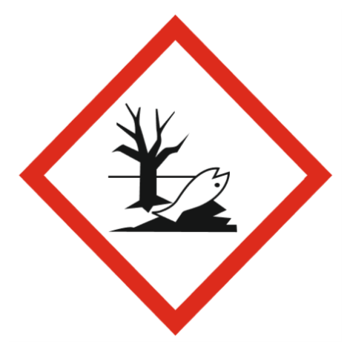
Hazardous to the envronment

Precautions Necessary

Further Action (If Applicable)

Actioned & Satisfactory

First Aid Measures

General First Aid Measures

Get medical advice/attention if you feel unwell.

After Skin Contact

Wash skin with plenty of water.

After Inhalation

Remove person to fresh air and keep comfortable for breathing.

Spillage

For containment: Collect spillage.
Methods for cleaning up: Soak up spills with inert solids, such as clay or diatomaceous earth as soon as possible.

☐ Yes

☐ No

Usage

Precautions for safe handling: Avoid contact with skin and eyes. Hygiene measures: Do not eat, drink or smoke when using this product.

☐ Yes

☐ No

Storage

Keep container closed when not in use.

☐ Yes

☐ No

Waste Treatment

Regional waste regulation: Dispose of in accordance with relevant local regulations.
Waste treatment methods: Dispose of contents/container in accordance with licensed collector’s sorting instructions.
Product/Packaging disposal recommendations: Dispose in a safe manner in accordance with local/national regulations.
European List of Waste (LoW, EC 2000/532): 20 01 29* - detergents containing dangerous substances

☐ Yes

☐ No

After Eye Contact

IF IN EYES: Rinse cautiously with water for several minutes. Remove contact lenses, if present and easy to do. Continue rinsing. If eye irritation persists: Get medical advice/attention.

After Ingestion

Do NOT induce vomiting. Rinse mouth. Drink plenty of water. Get medical advice/attention.

Personal Protective Equipment

Eye and Face Protection Requirements

Wear eye protection. Safety glasses. ISO 16321-1

Skin Protection

Skin and body protection: Not required for normal conditions of use.
Hand protection: In case of repeated or prolonged contact wear gloves. Chemical resistant gloves (according to European standard ISO 374-1 or equivalent). Nitrile rubber gloves.

Respiratory Protection

Not relevant

Measures for Monitoring (Including Health Surveillance where applicable)

No additional information available

Additional Considerations

Always maintain a good standard of occupational hygiene when handling chemicals. Avoid excessive skin contact. Use water proof gloves when necessary. When handling, do not eat, drink or smoke.



Fire Extinguishing Agent

Water

Foam

CO2

Dry Powder

