Product Name

Windmill Contester Unperfumed - Heavy Duty Degreaser - 1L - Windmill Refill Recharger

Supplier

AUK Hygiene | www.aukhygiene.com | 01626 355177

Location

Completed By

Signature of Assessor

Date of Assessment

Date of Next Assessment

MSDS Revision Date

09/03/2026

Issue: 15

ALWAYS READ THE LABEL AND FOLLOW INSTRUCTIONS

For surface cleaning, use product to remove soiling and visible dirt allowing contact time if required. Rinse the surface with clean water and a clean cloth before sanitising. For floor cleaning, dilute into bucket with warm water and mop floor.

COSHH RISK ASSESSMENT

CLP Classification

Hazard Statements

Causes severe skin burns and eye damage.

Intended Use

Kitchen Surface and Floor Degreasing

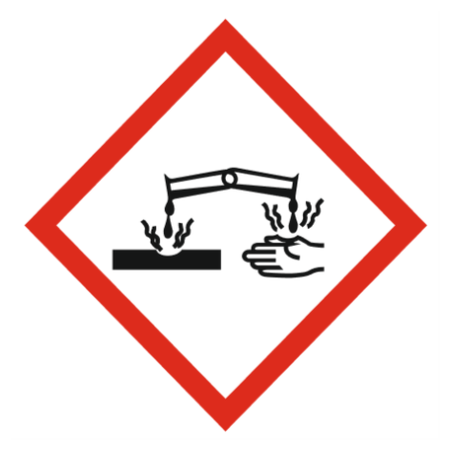
Corrosive

Precautions Necessary

Further Action (If Applicable)

Actioned & Satisfactory

First Aid Measures

General First Aid Measures

After Skin Contact

Wash immediately with water. Get medical attention promptly if symptoms occur after washing.

After Inhalation

Unlikely route of exposure as the product does not contain volatile substances. If spray/mist has been inhaled, proceed as follows. Move affected person to fresh air and keep warm and at rest in a position comfortable for breathing.

After Eye Contact

Rinse immediately with plenty of water. Remove any contact lenses, if present and easy to do, continue to rinse with eyelids apart. Get medical attention immediately.

After Ingestion

Do NOT induce vomiting. Rinse mouth thoroughly with water. Give plenty of water to drink. Get medical attention immediately.

Personal Protective Equipment

Eye and Face Protection Requirements

Chemical splash goggles or face shield.

Skin Protection

Wear protective gloves. Wear appropriate clothing to prevent any possibility of skin
contact.

Respiratory Protection

Respiratory protection not required.

Measures for Monitoring (Including Health Surveillance where applicable)

Additional Considerations

Always maintain a good standard of occupational hygiene when handling chemicals. Avoid excessive skin contact. Use water proof gloves when necessary. When handling, do not eat, drink or smoke.



Fire Extinguishing Agent

Water

Foam

CO2

Dry Powder

Spillage

Small Spillages: Flush away spillage with plenty of water to drain.
Large Spillages: Contain and absorb spillage with sand, earth or other non-combustible material.

☐ Yes

☐ No

Usage

Precautions for safe handling: Wear personal protective clothing

☐ Yes

☐ No

Storage

Keep container tightly closed in a cool, well-ventilated place.

☐ Yes

☐ No

Waste Treatment

Discharge used solutions to drain. Small amounts (less than 5 Litres) of unwanted product may be flushed with water to sewer. Larger volumes must be sent for disposal as special waste. Rinse out empty container with water and consign to normal waste.

☐ Yes

☐ No

